-------------------------

INSTALLING PODMAN

-------------------------

To install podman on a RHEL server system

[root@podman ~]# yum install podman -y

--------------------------------------

FIRST WE NEED CHECK THE PODMAN VERSION

--------------------------------------

[root@podman ~]# podman --version

podman version 4.0.2

[root@podman ~]# podman search httpd

NAME DESCRIPTION

registry.fedoraproject.org/f29/httpd

registry.access.redhat.com/rhscl/httpd-24-rhel7 Apache HTTP 2.4 Server

registry.access.redhat.com/cloudforms46-beta/cfme-openshift-httpd CloudForms is a management and automation platform for virtual, private, and hybrid cloud infrastructures. This image provides a Web Server in a multi-pod CloudForms OpenShift deployment.

registry.access.redhat.com/ubi8/httpd-24 Platform for running Apache httpd 2.4 or building httpd-based application

---------------------------------------------

PULLING A CONTANIER IMAGE TO THE LOCAL SYSTEM

---------------------------------------------

[root@podman ~]# podman pull httpd

✔ docker.io/library/httpd:latest

Trying to pull docker.io/library/httpd:latest...

Getting image source signatures

Copying blob 8740c948ffd4 done

Copying blob ec2ee6bdcb58 done

Copying blob 70698c657149 done

Copying blob 00df85967755 done

Copying blob 8b4456c99d44 done

Copying config 6e794a4832 done

Writing manifest to image destination

Storing signatures

6e794a4832588ca05865700da59a3d333e7daaaf0544619e7f326eed7e72c903

-------------------------------

LIST LOCAL CONTAINER IMAGES

-------------------------------

[root@podman ~]# podman images

REPOSITORY TAG IMAGE ID CREATED SIZE

docker.io/library/httpd latest 6e794a483258 2 weeks ago 149 MB

--------------------------------

RUNNING A THE CONTAINER IMAGES

---------------------------------

[root@podman ~]# podman run -dt --name todayimage 6e794a483258

53a3401e9153140eb1f28d221ed75f46b910c43d1fdab3627bed4a119e7904b4

------------------------------------

CHECKING THE RUNNING CONTAINERS

-------------------------------------

[root@podman ~]# podman ps

CONTAINER ID IMAGE COMMAND CREATED STATUS PORTS NAMES

53a3401e9153 docker.io/library/httpd:latest httpd-foreground 10 seconds ago Up 9 seconds ago todayimage

[root@podman ~]# podman exec -it 53a3401e9153 /bin/bash

root@53a3401e9153:/usr/local/apache2#

root@53a3401e9153:/usr/local/apache2# ls

bin build cgi-bin conf error htdocs icons include logs modules

[root@podman ~]# podman ps

CONTAINER ID IMAGE COMMAND CREATED STATUS PORTS NAMES

53a3401e9153 docker.io/library/httpd:latest httpd-foreground 2 minutes ago Up 2 minutes ago todayimage

----------------------------------------------------

LIST CONTAINERS THAT ARE RUNNING OR HAVE EXITED

----------------------------------------------------

[root@podman ~]# podman ps -a

CONTAINER ID IMAGE COMMAND CREATED STATUS PORTS NAMES

53a3401e9153 docker.io/library/httpd:latest httpd-foreground 2 minutes ago Up 2 minutes ago todayimage

[root@podman ~]# podman stop 53a3401e9153

53a3401e9153

[root@podman ~]# podman ps

CONTAINER ID IMAGE COMMAND CREATED STATUS PORTS NAMES

[root@podman ~]# podman ps -a

CONTAINER ID IMAGE COMMAND CREATED STATUS PORTS NAMES

53a3401e9153 docker.io/library/httpd:latest httpd-foreground 3 minutes ago Exited (0) 18 seconds ago todayimage

-----------------------------

CREATING THE DOCKERFILE

-----------------------------

[root@podman ~]# cat Dockerfile

FROM ubi7

MAINTAINER gumma harish

RUN yum install httpd -y

RUN echo "Hello world" > /var/www/html/index.html

EXPOSE 8085

CMD ["httpd", "-D", "FOREGROUND"]

--------------------------------------

BULID A CONTAINER

-------------------------------------

[root@podman ~]# podman build -t ubi7 .

STEP 1/6: FROM ubi7

Resolved "ubi7" as an alias (/etc/containers/registries.conf.d/001-rhel-shortnames.conf)

Trying to pull registry.access.redhat.com/ubi7:latest...

Getting image source signatures

Checking if image destination supports signatures

Copying blob 7597778323f6 done

Copying config f0c1470d8c done

Writing manifest to image destination

Storing signatures

STEP 2/6: MAINTAINER gumma harish

--> 74e8ee807a7

STEP 3/6: RUN yum install httpd -y

Loaded plugins: ovl, product-id, search-disabled-repos, subscription-manager

This system is not receiving updates. You can use subscription-manager on the host to register and assign subscriptions.

Resolving Dependencies

--> Running transaction check

---> Package httpd.x86_64 0:2.4.6-98.el7_9.6 will be installed

--> Processing Dependency: httpd-tools = 2.4.6-98.el7_9.6 for package: httpd-2.4.6-98.el7_9.6.x86_64

--> Processing Dependency: system-logos >= 7.92.1-1 for package: httpd-2.4.6-98.el7_9.6.x86_64

--> Processing Dependency: /etc/mime.types for package: httpd-2.4.6-98.el7_9.6.x86_64

--> Processing Dependency: libapr-1.so.0()(64bit) for package: httpd-2.4.6-98.el7_9.6.x86_64

--> Processing Dependency: libaprutil-1.so.0()(64bit) for package: httpd-2.4.6-98.el7_9.6.x86_64

--> Running transaction check

---> Package apr.x86_64 0:1.4.8-7.el7 will be installed

---> Package apr-util.x86_64 0:1.5.2-6.el7 will be installed

---> Package httpd-tools.x86_64 0:2.4.6-98.el7_9.6 will be installed

---> Package mailcap.noarch 0:2.1.41-2.el7 will be installed

---> Package redhat-logos.noarch 0:70.7.0-1.el7 will be installed

--> Finished Dependency Resolution

Dependencies Resolved

================================================================================

Package Arch Version Repository Size

================================================================================

Installing:

httpd x86_64 2.4.6-98.el7_9.6 ubi-7 1.2 M

Installing for dependencies:

apr x86_64 1.4.8-7.el7 ubi-7 104 k

apr-util x86_64 1.5.2-6.el7 ubi-7 92 k

httpd-tools x86_64 2.4.6-98.el7_9.6 ubi-7 94 k

mailcap noarch 2.1.41-2.el7 ubi-7 31 k

redhat-logos noarch 70.7.0-1.el7 ubi-7 13 M

Transaction Summary

================================================================================

Install 1 Package (+5 Dependent packages)

Total download size: 15 M

Installed size: 18 M

Downloading packages:

warning: /var/cache/yum/x86_64/7Server/ubi-7/packages/apr-1.4.8-7.el7.x86_64.rpm: Header V3 RSA/SHA256 Signature, key ID fd431d51: NOKEY

Public key for apr-1.4.8-7.el7.x86_64.rpm is not installed

--------------------------------------------------------------------------------

Total 4.2 MB/s | 15 MB 00:03

Retrieving key from file:///etc/pki/rpm-gpg/RPM-GPG-KEY-redhat-release

Importing GPG key 0xFD431D51:

Userid : "Red Hat, Inc. (release key 2) <security@redhat.com>"

Fingerprint: 567e 347a d004 4ade 55ba 8a5f 199e 2f91 fd43 1d51

Package : redhat-release-server-7.9-6.el7_9.x86_64 (@anaconda/7.9)

From : /etc/pki/rpm-gpg/RPM-GPG-KEY-redhat-release

Importing GPG key 0x2FA658E0:

Userid : "Red Hat, Inc. (auxiliary key) <security@redhat.com>"

Fingerprint: 43a6 e49c 4a38 f4be 9abf 2a53 4568 9c88 2fa6 58e0

Package : redhat-release-server-7.9-6.el7_9.x86_64 (@anaconda/7.9)

From : /etc/pki/rpm-gpg/RPM-GPG-KEY-redhat-release

Running transaction check

Running transaction test

Transaction test succeeded

Running transaction

Installing : apr-1.4.8-7.el7.x86_64 1/6

Installing : apr-util-1.5.2-6.el7.x86_64 2/6

Installing : httpd-tools-2.4.6-98.el7_9.6.x86_64 3/6

Installing : redhat-logos-70.7.0-1.el7.noarch 4/6

Installing : mailcap-2.1.41-2.el7.noarch 5/6

Installing : httpd-2.4.6-98.el7_9.6.x86_64 6/6

Verifying : httpd-2.4.6-98.el7_9.6.x86_64 1/6

Verifying : httpd-tools-2.4.6-98.el7_9.6.x86_64 2/6

Verifying : mailcap-2.1.41-2.el7.noarch 3/6

Verifying : apr-1.4.8-7.el7.x86_64 4/6

Verifying : apr-util-1.5.2-6.el7.x86_64 5/6

Verifying : redhat-logos-70.7.0-1.el7.noarch 6/6

Installed:

httpd.x86_64 0:2.4.6-98.el7_9.6

Dependency Installed:

apr.x86_64 0:1.4.8-7.el7 apr-util.x86_64 0:1.5.2-6.el7

httpd-tools.x86_64 0:2.4.6-98.el7_9.6 mailcap.noarch 0:2.1.41-2.el7

redhat-logos.noarch 0:70.7.0-1.el7

Complete!

--> 2cbb2c32089

STEP 4/6: RUN echo "Hello world" > /var/www/html/index.html

--> f4e267984d2

STEP 5/6: EXPOSE 8085

--> 15953bece3b

STEP 6/6: CMD ["httpd", "-D", "FOREGROUND"]

COMMIT ubi7

--> 7605d5233f5

Successfully tagged registry.access.redhat.com/ubi7:latest

7605d5233f54a2c459188a93b7e9542e0bf252053646ee030d6dc43e5ae13913

[root@podman ~]# podman images

REPOSITORY TAG IMAGE ID CREATED SIZE

registry.access.redhat.com/ubi7 latest 7605d5233f54 About a minute ago 257 MB

-------------------------------------------

PUSHING THE IMAGE TO THE QUAY.iO REPOSITORY

-------------------------------------------

[root@podman ~]# podman push 7605d5233f54 quay.io/gummaharish66/httpd

Getting image source signatures

Copying blob 004f8c3f54bc done

Copying blob ac40fbf2c07d done

Copying blob a6d542167482 done

Copying config 7605d5233f done

Writing manifest to image destination

Storing signatures

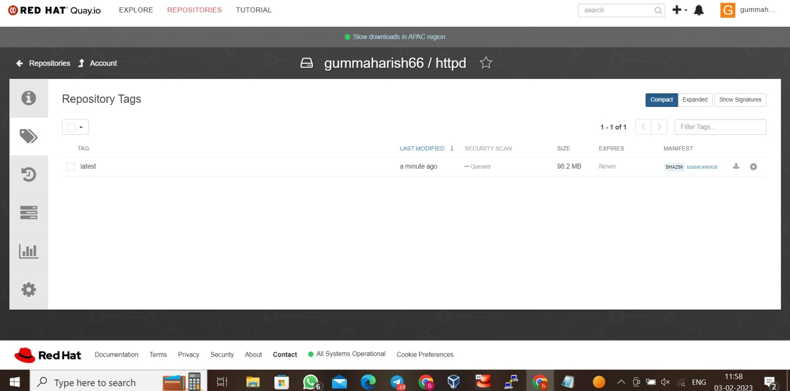

---------------------------------------------

PORT MAPPING

----------------------------------------------

[root@podman ~]# podman run -dt --name newlyimage -p 8080:8090 7605d5233f54

6ec0fd6ae7192d4d7cd834e9872c2bdc20b0f0fee11e99ce808f4450c90370fc

[root@podman ~]# podman ps

CONTAINER ID IMAGE COMMAND CREATED STATUS PORTS NAMES

6ec0fd6ae719 registry.access.redhat.com/ubi7:latest httpd -D FOREGROU... 13 seconds ago Up 13 seconds ago 0.0.0.0:8080->8090/tcp newlyimage

[root@podman ~]# podman exec -it 6ec0fd6ae719 /bin/bash

[root@6ec0fd6ae719 /]#

[root@6ec0fd6ae719 ~]# cd /var/www/html/

[root@6ec0fd6ae719 html]# cat index.html

Hello world

--------------------------------

PODMAN INSPECT

---------------------------------

[root@podman ~]# podman inspect 6ec0fd6ae719 | grep "IPA"

"IPAddress": "10.88.0.6",

"IPAddress": "10.88.0.6",

"IPAMConfig": null,

---------------------------------

CREATING PERSISTENT VOLUME

----------------------------------

[root@podman ~]# mkdir volume1

[root@podman ~]#

[root@podman ~]#

[root@podman ~]# ls

anaconda-ks.cfg Desktop Dockerfile Documents Downloads initial-setup-ks.cfg Music Pictures Public Templates Videos volume1

[root@podman ~]# podman run -d --name newbuild -v /root/volume1:/mnt/:Z 7605d5233f54

6ad40b6ec5af508958f0a474d0178fd32f3230a8cc7efcc1792c56d7e2746fc2

[root@podman ~]# podman ps

CONTAINER ID IMAGE COMMAND CREATED STATUS PORTS NAMES

6ad40b6ec5af registry.access.redhat.com/ubi7:latest httpd -D FOREGROU... 20 seconds ago Up 20 seconds ago newbuild

[root@podman ~]# podman exec -it 6ad40b6ec5af /bin/bash

[root@6ad40b6ec5af /]#

[root@6ad40b6ec5af /]# ls

bin boot dev etc home lib lib64 media mnt opt proc root run sbin srv sys tmp usr var

-------------------------------------

INSIDE THE CONTAINER

-------------------------------------

[root@6ad40b6ec5af /]# cd mnt

[root@6ad40b6ec5af mnt]# ls

[root@6ad40b6ec5af mnt]# touch hello

[root@6ad40b6ec5af mnt]# touch file{1..5}

[root@6ad40b6ec5af mnt]# ls

file1 file2 file3 file4 file5 hello

-------------------------------

OUTSIDE THE CONTAINER

--------------------------------

[root@podman ~]# cd volume1/

[root@podman volume1]# ls

file1 file2 file3 file4 file5 hello

[root@podman volume1]# touch hello{1..9}

[root@podman volume1]# ls

file1 file3 file5 hello1 hello3 hello5 hello7 hello9

file2 file4 hello hello2 hello4 hello6 hello8

[root@podman volume1]#

[root@6ad40b6ec5af mnt]# ls

file1 file2 file3 file4 file5 hello hello1 hello2 hello3 hello4 hello5 hello6 hello7 hello8 hello9

